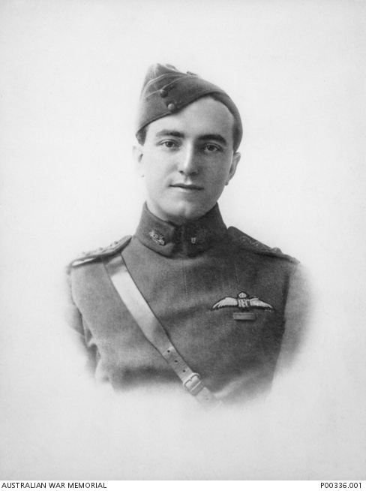
Air Vice Marshal Francis Hubert (Frank) McNamara, VC, CB, CBE
Date of birth: 04 April 1894
Place of birth: Rushworth, VIC
Date of death: 02 November 1961
Place of death: London, England
Frank McNamara was the first Australian airman to be awarded the Victoria Cross. He was born at Rushworth, Victoria, on 4 April 1894. Having completed his secondary schooling in Shepparton, McNamara studied teaching at the Teachers Training College and the University of Melbourne.
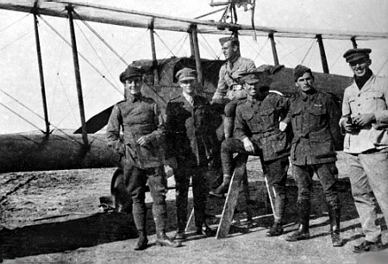
He taught at a number of Victorian Schools including the Princes Hill School and joined the Senior Cadets in 1911. The following year he transferred to the Brighton Rifles and was commissioned as a second lieutenant in July 1913. In the early months of the First World War he served at Queenscliff and then Point Nepean before attending the Officers Training School at Broadmeadows. Between February and May 1915 he instructed at the AIF Training Depot at Broadmeadows.
In August 1915 McNamara was selected to attend the Point Cook Flying School, graduating as a pilot in October that year. He was posted to No. 1 Squadron, Australian Flying Corps, as an adjutant in January 1916 and sailed for Egypt. In May 1916 he left for an attachment to No. 42 Squadron, Royal Flying Corps to attend the Central Flying School at Upavon, England. Upon completing his course he was attached to No. 22 Squadron of the Royal Flying Corps as an instructor in Egypt before returning to duty with No. 1 Squadron.
Frank McNamara far left, Egypt may 1917

On 20 March 1917, McNamara, flying a Martinsyde, was one of four No. 1 Squadron pilots taking part in a raid against a Turkish railway junction near Gaza. Owing to a shortage of bombs, the aircraft were each armed with six specially-modified 4.5-inch howitzer shells. McNamara had successfully dropped three of his shells when the fourth exploded prematurely, badly wounded him in the leg with shrapnel, an effect he likened to being "hit with a sledgehammer". Having turned to head back to base, he spotted a fellow squadron member from the same mission, Captain David Rutherford, on the ground beside his crash landed B.E.2. Allied airmen had been hacked to death by enemy troops in similar situations, and McNamara saw that a company of Turkish cavalry was fast approaching Rutherford's position. Despite the rough terrain and the gash in his leg, McNamara landed near Rutherford in an attempt to rescue him. As there was no spare cockpit in the single-seat Martinsyde, the downed pilot jumped on to McNamara's wing and held the struts. McNamara crashed while attempting to take off, however, due to the effects of his leg wound and Rutherford's weight overbalancing the aircraft. The two men, who had escaped further injury in the accident, set fire to the Martinsyde and dashed back to Rutherford's two-seat B.E.2. Rutherford repaired the engine while McNamara used his revolver against the attacking cavalry, who had opened fire on them. Two other No. 1 Squadron pilots overhead, Lieutenant (later Air Marshal Sir) Roy "Peter" Drummond and Lieutenant Alfred Ellis, also began strafing the enemy troops. McNamara managed to start the B.E.2's engine and take off, with Rutherford in the observer's cockpit. In severe pain and close to blacking out from loss of blood, McNamara flew the damaged aircraft 70 miles back to base at El Arish.
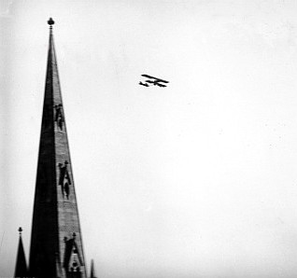
Having effected what was described in the Australian official history of the war as "a brilliant escape in the very nick of time and under hot fire", McNamara "could only emit exhausted expletives" before he lost consciousness shortly after landing. Evacuated to hospital, he almost died following an allergic reaction to a routine tetanus injection. McNamara had to be given artificial respiration and stimulants to keep him alive, but recovered quickly. A contemporary news report declared that he was "soon sitting up, eating chicken and drinking champagne". On 26 March, McNamara was recommended for the Victoria Cross by Brigadier General Geoffrey Salmond, General Officer Commanding the Middle East Brigade, RFC. Drummond, Ellis, and Rutherford all wrote statements on 3–4 April attesting to their comrade's actions, Rutherford declaring that "the risk of Lieut. McNamara being killed or captured was so great that even had he not been wounded he would have been justified in not attempting my rescue – the fact of his already being wounded makes his action one of outstanding gallantry – his determination and resource and utter disregard of danger throughout the operation was worthy of the highest praise". This was the first and only VC won by an Australian airman in World War I.
He was promoted to captain and appointed Flight Commander in April 1917, but his wound prevented further flying and he was invalided to Australia in August that year. His appointment with the Australian Flying Corps ended in January 1918 but he was reappointed in September and became an aviation instructor. In 1921 McNamara transferred to the newly established Royal Australian Air Force as a flight lieutenant. He held a number of senior RAAF appointments between the wars, and spent two years on exchange to the RAF in the mid-1920s.
At the beginning of the Second World War, McNamara was promoted to air commodore and, in 1942, air vice marshal. Between 1942 and 1945 he served as Air Officer Commanding British Forces in Aden before returning to London as the RAAF's representative at Britain's Ministry of Defence. In July 1946 he became Director of Education at the headquarters of the British Occupation Administration in Germany.
Captain McNamara flying an Avro 504K over St Patrick's Cathedral Melbourne c20 He was later married in the cathedral
McNamara retired in England and died in London on 2 November 1961.

